We used the program http://www.artisancam.org.uk/flashapps/sculpturama/sculpturama.php?PHPSESSID=e22f06c94e1a1ea455cb7523daca56f7
Here are pictures of us making the stone sculpture:
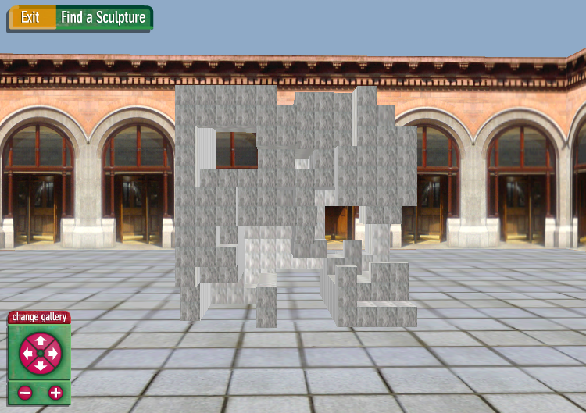

Here are the comments by the class, discussing preferences and how we made the sculpture.
- We are making a sculpture. Stone is heavy.
- We chose from different stones: red sandstone (Lily), marble (Cool), yellow sandstone (Ellen), Granite (Jae Hun).
- We made our sculpture from marble stone.
- It is very expensive.
- We used a saw to cut through the marble.
We made this one next.
